Setup for Samba on CentOS 7
Samba is an open-source software suite that runs on Unix/Linux based platforms but can communicate with Windows clients like a native application. So Samba is able to provide this service by employing the Common Internet File System (CIFS).
At the heart of this CIFS is the Server Message Block (SMB) protocol. Samba does this by performing these 4 key things –
- File & print services
- Authentication and Authorization
- Name resolution
- Service announcement (browsing)
Samba can be run on many different platforms including Linux, Unix, OpenVMS and operating systems other than Windows and allows the user to interact with a Windows client or server natively. It can basically be described as the Standard Windows interoperability suite of programs for Linux and Unix.
Note that we will create two forms of Samba server, one setup won’t require a password to share files with any client on the network which is the anonymous share and another setup will require setting up users and permissions.
The main samba configuration file is /etc/samba/smb.conf

Linux PC – 192.168.8.11/24
Windows PC – 192.168.8.12/24

Step 1: Install Samba server on CentOS 7
a. Install the samba server using yum install command
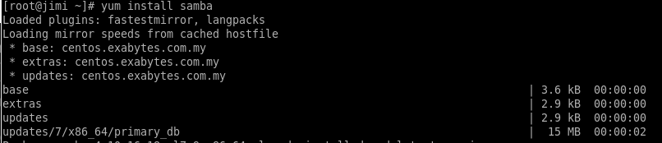
b. Start SMB and NMB services.
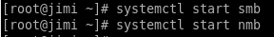
c. Enable SMB and NMB services
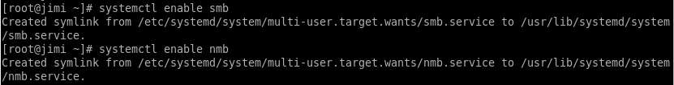

Step 2: Configure CentOS 7 Firewalld
a. Configure Firewalld to allow access to the SMB service on the CentOS Samba Server
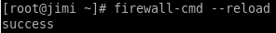

Step 3: Create Samba user and setup password
We are going to need a username and password to access our CentOS Samba Share from a remote computer.
a. Create a new user called “sambauser”.
b. Setup samba password for sambauser using the smbpasswd command.
Password: sambauser
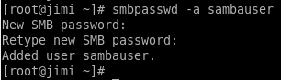

Step 4: Configure File Server – Anonymous Share
a. Create a shared folder called “anonymous_share’”.

b. ​Allow anyone to access and store (read/execute) files in folder.

c. Edit configuration file to enable sharing.​
Make a backup of the configuration file before editing
d. Open the conf file and make the following changes:
Change the to windows default workgroup
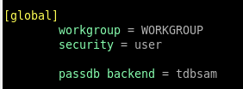
Add the following lines at the bottom
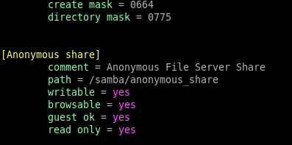
e. Save the /etc/samba/smb.conf file and restart the CentOS samba server.

Step 5: Test the Samba Server Configuration
To verify that the parameters are correct in the smb.conf file or to debug configuration problems, use the testparm command.
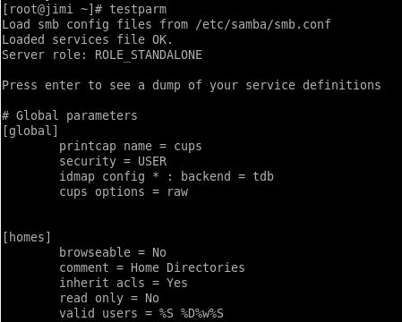

Step 6: Configure File Server – Secured Share
a. ​Create shared folder called “securedfolder”.

b. ​Create a new user group named “selected”.

c. ​Modify permission and ownership for the folder.

d. Edit configuration file to allow sharing
​Make a backup of the configuration file before editing.
e. Open the conf file and make the following changes –
Add the following at the end of the file to enable sharing –

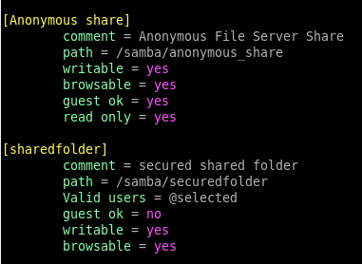
f. Save the /etc/samba/smb.conf file and restart the CentOS samba server.
g. Once Samba has restarted, use this command to check your smb.conf for any syntax errors. Testparm
h. Create and add a user “Jack” to the user group “selected” with restricted shell access.
i. To add a password for the user
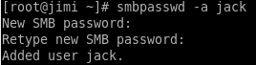
Password: jack
CLIENT (WINDOWS 7)
1. Make sure the Windows machine is in the same workgroup to be configured on the CentOS server.
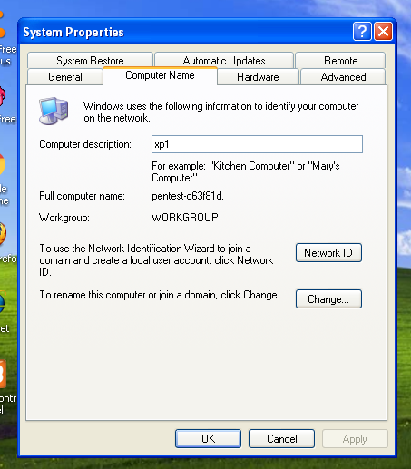
2. Access the server using its IP address
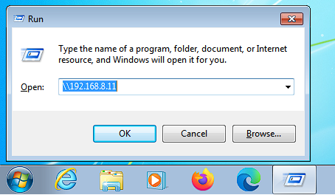
3. You’ll be able to access the fully accessed samba shares.
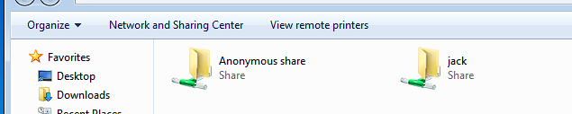
4. open the Anonymous directory and try to add files in there to share with other users.

